Releases notes v1.09


Releases notes
v1.09
Bugs & Change 3
Improvement 4
Purchase list in product information #339 4
Show how many time, publique page is loaded #340 4
Create delevery from order lines #344 5
Produce Parts traceability (serial number… #347 5
API for quote #350 6
Move card alterte in modal #351 7
Converte delevery note to invoice in note interface #352 7
Price by Qt, per supplier #341 8
Custom fields#342 8
Invoice Add statu#356 9
User Activity Logging and Invoice Payment Status #355 9
Workshop interface #349 10
Be able to create an invoice, without Delevery note #372 10
Add Chat on task / quotes / orders #343 11
Import CSV BOM #376 12
Add standard nomenclature to line #377 12
Have a common display, technical breakdown / BOM #378 13
Create next and previous task #380 13
Radquote Quote import #255 14

Bugs & Change

#345 - Export line looks not working
#354 - Not allow line without article if is an internal order
#358 - Remove duplicated columns in migration script
#360 - Upgrade base image to make composer work
#363 Fix the issue introduced in #361
#361 - Call Factory::first once and cache the result in FactoryServiceProvider
#362 - Loading dashboard is slow when MySQL server is running in a remote site.
#366 - Translate some words from French to English
#364 - Some small refactoring
#365 - Fix mismatch of suppliers and clients in dashboard
#368 - Change redundant conditions in OpportunitiesController
#370 - [REFACTORING] next / previous button
#375 - [Packtage] update jeroennoten / Laravel-AdminLTE
#374 - [API] Company & Task
#371 - [SECURITY] Crypt personal datas
#382 - Wrong select unit list

Improvement

Purchase list in product information #339

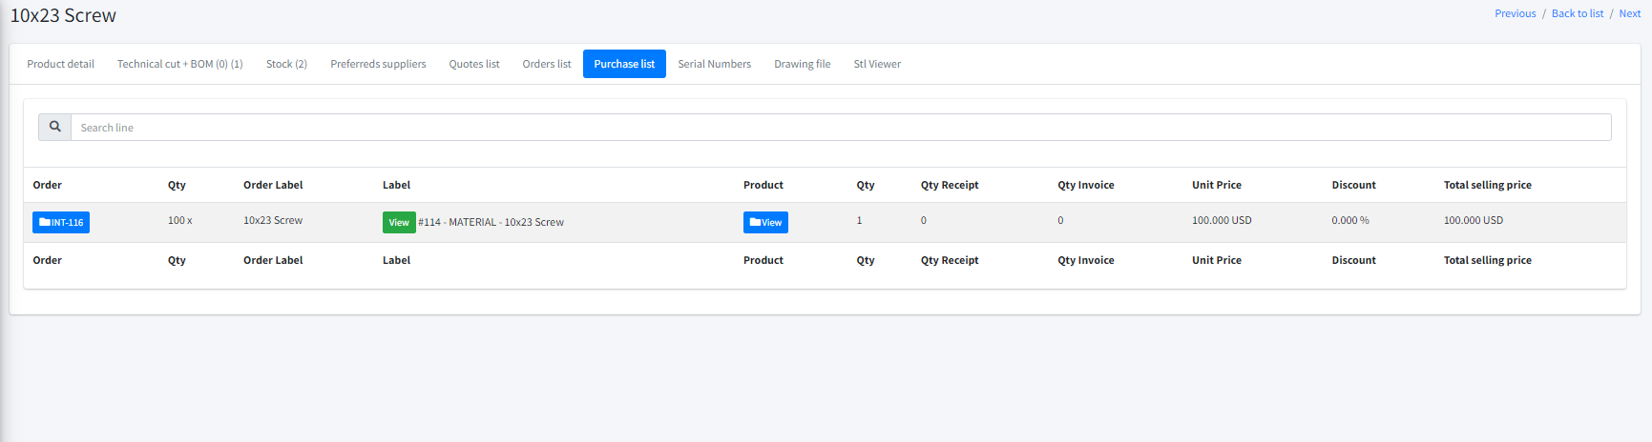

Show how many time, publique page is loaded #340

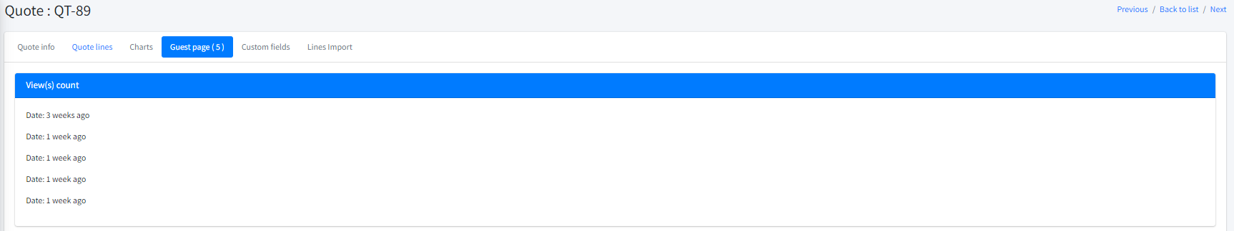

Create delevery from order lines #344
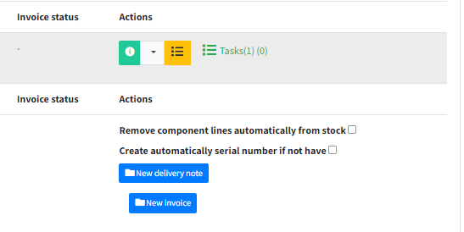

Produce Parts traceability (serial number… #347
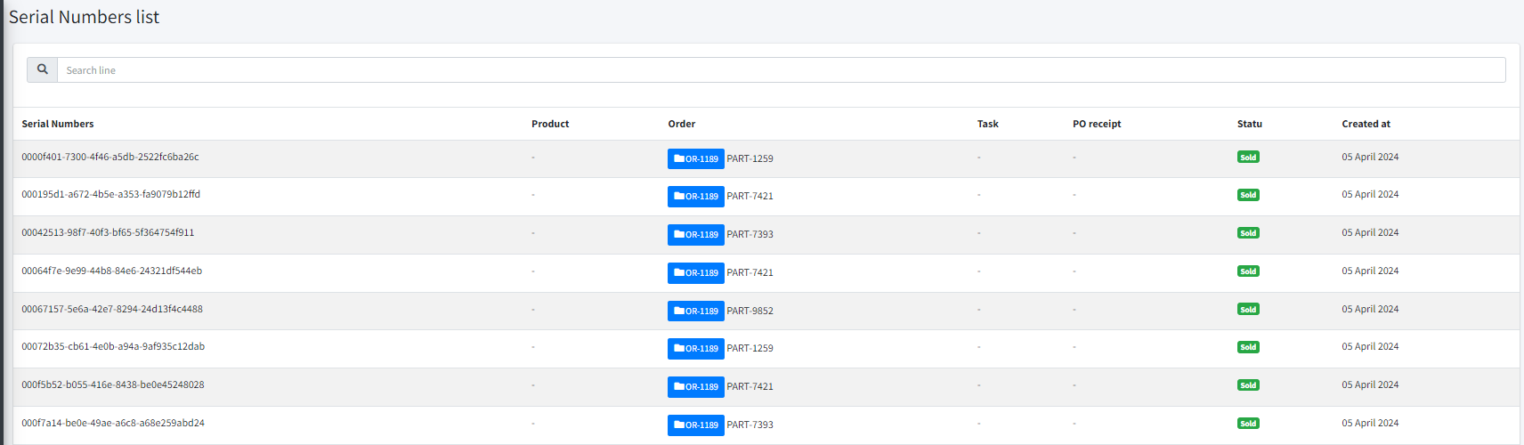

API for quote #350

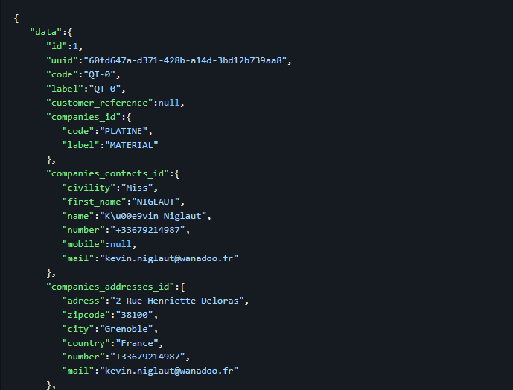

Move card alterte in modal #351
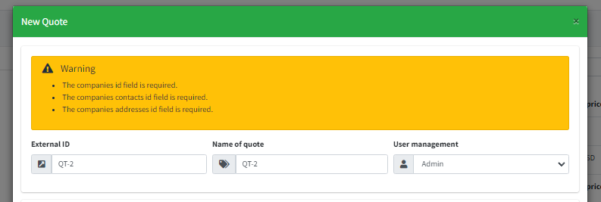

Converte delevery note to invoice in note interface #352
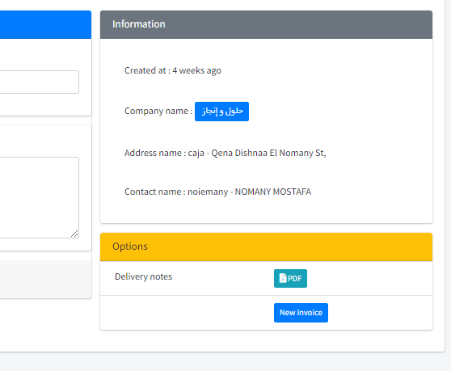

Price by Qt, per supplier #341
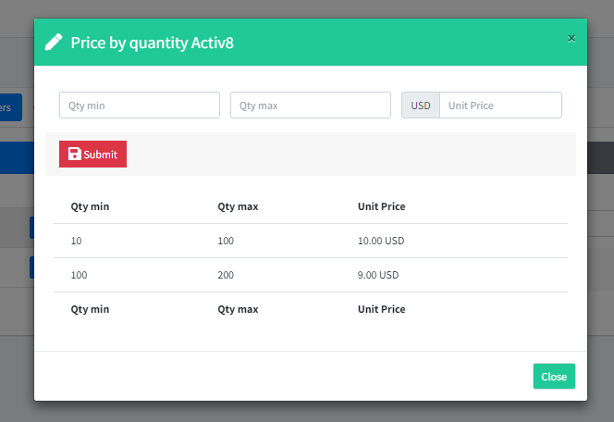

Custom fields#342
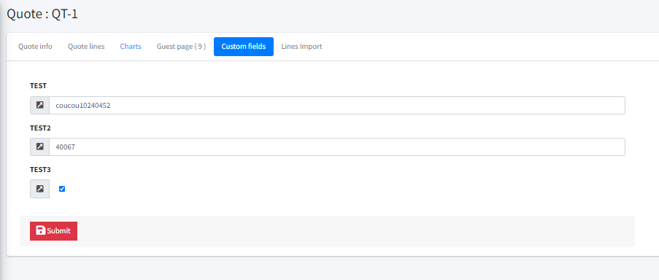

Invoice Add statu#356
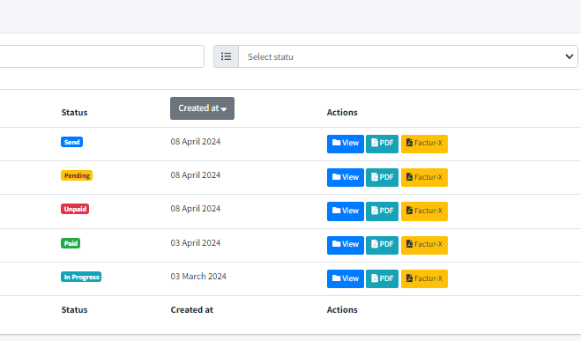

User Activity Logging and Invoice Payment Status #355
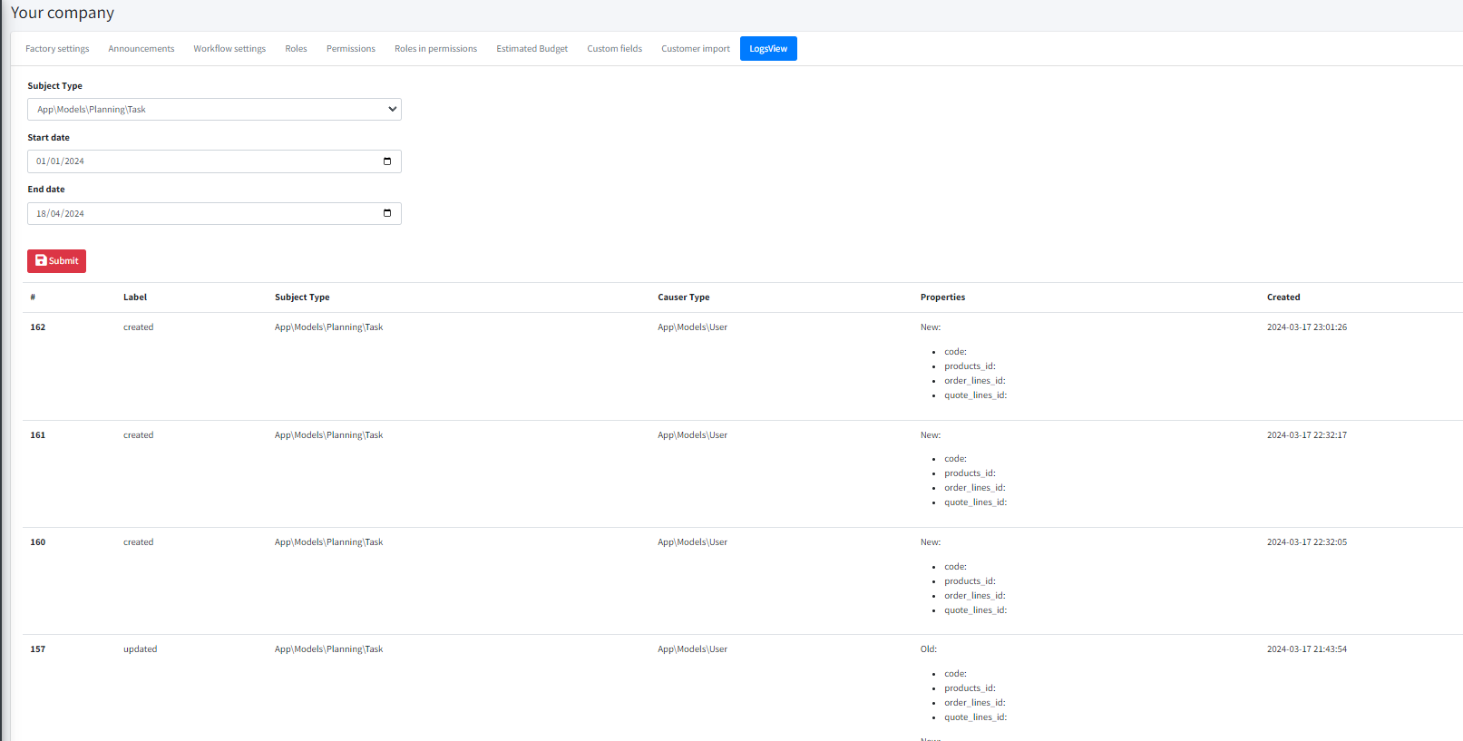

Workshop interface #349
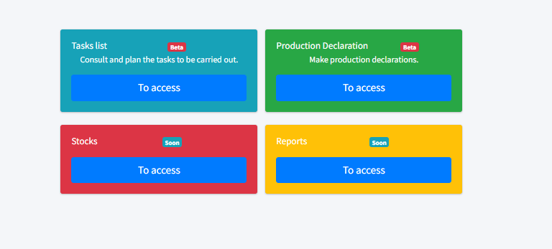

Be able to create an invoice, without Delevery note #372

Add Chat on task / quotes / orders #343

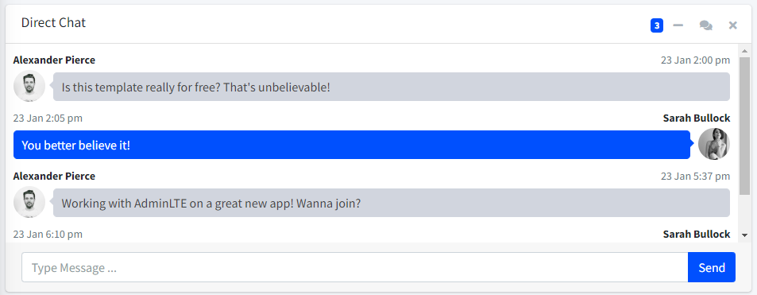

Import CSV BOM #376

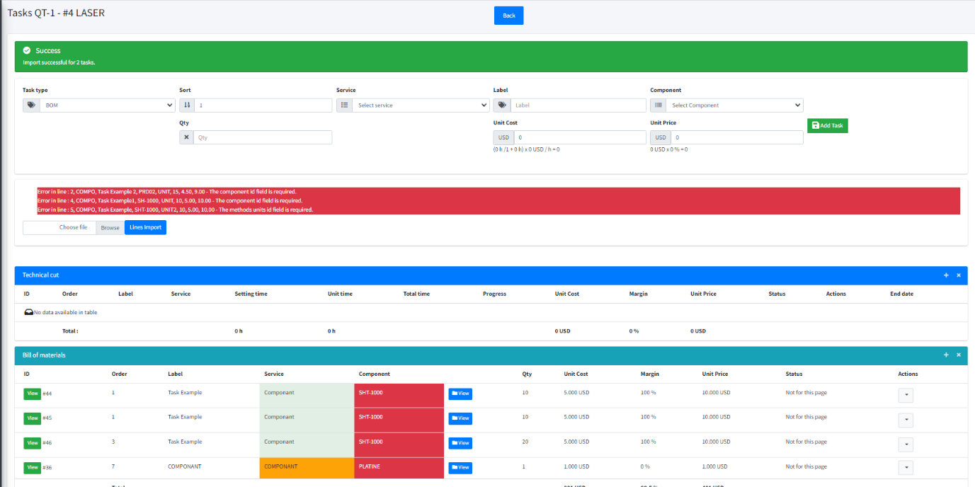

Add standard nomenclature to line #377

Have a common display, technical breakdown / BOM #378
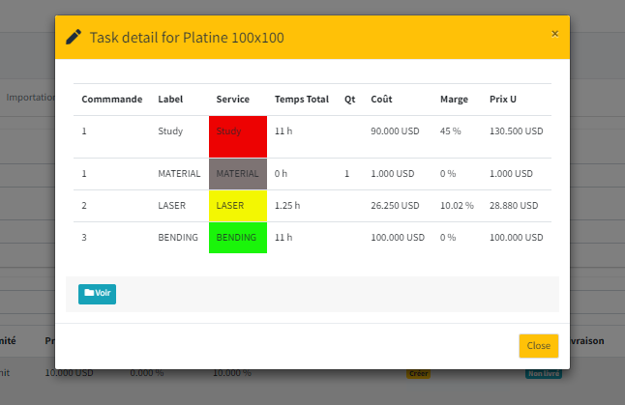

Create next and previous task #380

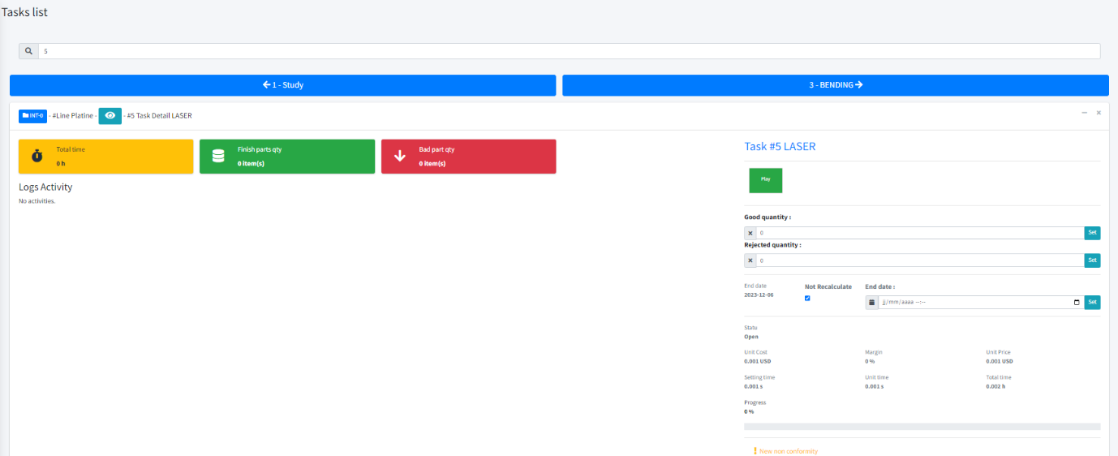

Radquote Quote import #255

